Indian School of Business

Data Visualization

Instructor:

Dr. John F. Tripp, Clemson University, [jftripp@clemson.edu](mailto:jftripp@clemson.edu)

**Tutorial 2**

**ASSIGNMENT TYPE: 0N**

You **MAY** discuss general concepts and ideas relevant to the assignment with others

You **MAY** discuss specific issues associated with the assignment with others

You **MAY** refer to external material

You **MAY** case-study solutions or problem set solutions

**PART ONE:**

**Attempt to answer business questions with Tableau.**

Download the Tutorial 2.twbx file from LMS.

This workbook has information about movies, the studios that created them, and their profitability.

**Step 1: Add a “Global” Filter (see the Filtering in Tableau Video)**

Create a filter at the appropriate level so that data records with a “Null” lead studio are not available to be used in ANY visualization.

**There is no filter type called “global”, but use the proper filter type that will be globally effective.

**Step 2: Create the following visualization.**

Show the rank order of movie studios, by profitability, excluding Disney. Show the labels at the end of each bar. Ensure that you edit the X axis to have the label “Profitability (In Millions)”

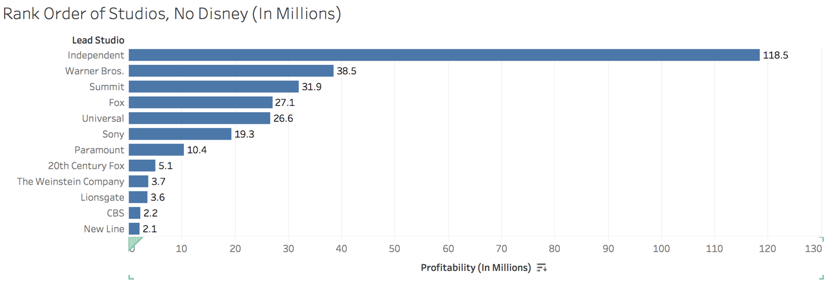

**Step 3: Create Visualizations that Answer the Following Questions**

Create a different visualization to answer each of these questions:

1. What is the percent change in profitability from 2008-2009 for movies where DISNEY is the lead studio? (A table calculation will make this easy)
2. What is the % difference, on average, between the rotten tomato score for Sony, as compared with the audience score? (You should create a calculated field to do this)
3. What is the worldwide gross for the genre of Drama, for the 5th highest grossing studio? (Create a viz that ranks the studios by worldwide gross, and then ranks the genres for each studio by worldwide gross. This is almost the same as the nested sort exercise from in-class).

**Step 4: Submit your PACKAGED Workbook on LMS.**